Part 3. Temporal Travel Pattern Analysis
3.1 Introduction
University campuses function as important nodes of urban mobility. They generate and attract large volumes of daily trips, which are determined by the cycles of academic life. Unlike conventional commuter flows, primarily driven by employment cycles, travel demand among university commuters is structured around a distinct institutional cycle, with teaching and vacation periods alternating throughout the year.
This section presents a temporal analysis of travel patterns originating from the four main university campuses in Singapore: the National University of Singapore (NUS) in Kent Ridge, Nanyang Technological University (NTU in Boon Lay, Singapore Management University (SMU) at Bras Basah, and the Singapore University of Technology and Design (SUTD) at Tampines. Using monthly origin-destination (OD) tap data from the Land Transport Authority (LTA), the analysis examines how trip volumes fluctuate across academic periods, how intra-day travel patterns differ between universities and periods, and how the functional character of destinations shifts over time. These analyses provide a temporal account of how university communities engage with Singapore’s urban environment through public transport.
3.2 Literary Review
Transit ridership is shaped by a combination of climatic, social, and institutional factors that produce recurring seasonal patterns. Kashfi et al. (2015) demonstrated that academic and school holiday periods constitute a distinct dimension of transit seasonality, showing that university and school calendars have a stronger influence on daily bus ridership than conventional natural calendar seasons alone. Their analysis of Brisbane’s suburban transit network segmented the year into nine blocks, which include the university semesters and holiday periods. They found that this institutional calendar structure outperformed the standard four-season model in predicting ridership behavior. Within the university context, travel behavior has been shown to be a habitual pattern even when the primary motivation of travel, which is attending campus, is temporarily removed. Verplanken et al. (1997) found that individuals with stronger travel habits engaged in less deliberate decision-making and acquired less information when choosing how to travel, suggesting that habitual travel behavior becomes automatic and is less responsive to contextual changes. This concept of habit inertia is relevant to the interpretation of the temporal stability of intra-day travel distributions. These works suggest that institutional calendars modulate the volume of university campus travel, while habitual behaviors may dictate the structure, a distinction that frames the analysis below.
3.3 Methodology
3.3.1 Period Classification
The primary source of data comes from the LTA monthly OD dataset, which records aggregate tap-in and tap-out transactions for all bus and MRT services in Singapore. The Data was obtained for the 12-month period from August 2024 to July 2025, corresponding to the Academic Year 2024-2025. From the full dataset, records were filtered to retain only the trips originating from the 83 bus stops and MRT stations identified in Section 2. Each origin station was assigned to its corresponding university based on its mapping; this provides us with a campus-attributed OD dataset for subsequent analysis.
Each month in the study period was assigned to one of the three academic period categories based on the NUS institutional calendar. The categories are: Semester Months (August through October; Febuary through April for Semester 2), during which regular teaching and campus activities take place; Examination/Break months (November and May), corresponding to the examination period at the end of each semester as well as the Vacation months (December, January, June, July), which are the inter semester breaks, where formal teaching stops. Board-categorical assignments were preferred over institution-specific date ranges to produce a classification that allows us to generalize across all four universities, which operate on similar but not identical calendars.
3.3.2 Monthly Volume Analysis
Trip volumes for each university were totaled monthly and analyzed as a time series over the study period. Shading was added to the time series to mark academic periods, making it easier to visually spot connections between school schedules and overall mobility patterns. To help with cross-university comparison independent of absolute trip volumes, which differ due to campus size and station count discrepancies, monthly volumes were additionally normalized within each university using a z-score, computed as the number of standard deviations above or below each university’s own mean monthly trip count
3.3.3 Semester-vacation comparison
Mean monthly trip volumes were computed for each combination of university and academic period category. Variability within each period was characterized using the standard error of the mean across months within that period. This was presented as error bars in the visualization.
3.3.4 Intra-day analysis
Weekday trip records were disaggregated by departure hour and grouped into four time-of-day categories: morning (0600 to 1000 hours), afternoon (1000 to 1600 hours), evening (1600 to 2200 hours), and night (2200 to 0600 hours). The share of the trip within each group was computed for each combination of university and academic period. This allows for the comparison of intra-day temporal structures across different schools and across the academic calendar. Weekday records were used solely for this analysis to isolate campus-driven travel signals from leisure-oriented patterns, which may act as noise on weekends.
3.3.5 Destination Function Analysis
Trip destinations were cross-referenced with the LDA-derived urban function classifications produced from Section 2, which assigns each of the 83 stations a dominant function label based on the composition of nearby points of interest (POI) in the Overture Maps dataset. For each period combination, the proportion of trips directed towards each function type was computed, allowing for the assessment of whether the functional character of destination shifts between term time and vacation periods. A stacked area chart was produced just for NUS to visualize how the destination function shares evolved on a monthly basis across the entire study period.

3.4 Results
3.4.1 Monthly Trip Volume
NUS consistently had the highest monthly trip volumes among universities, with about 1.1 to 1.2 million trips during semesters, while SUTD had the lowest at 200,000 to 250,000 trips per month. From Figure 1, the difference reflects the relative sizes and station counts of each campus. Across universities, there are discernible dips in trip volume during the Exam and Vacation periods. The most pronounced drop in traffic patterns in December of 2024 was for NTU, which saw volumes fall to near 150,000 trips, which is the lowest point during the vacations. NUS, on the other hand, declined to around 750,000 trips before recovering in February 2025. SMU and SUTD exhibited comparatively flatter seasonal changes; their trip volumes are less sensitive to the academic calendar, which, in the case of SMU, could be a result of its more urban location.
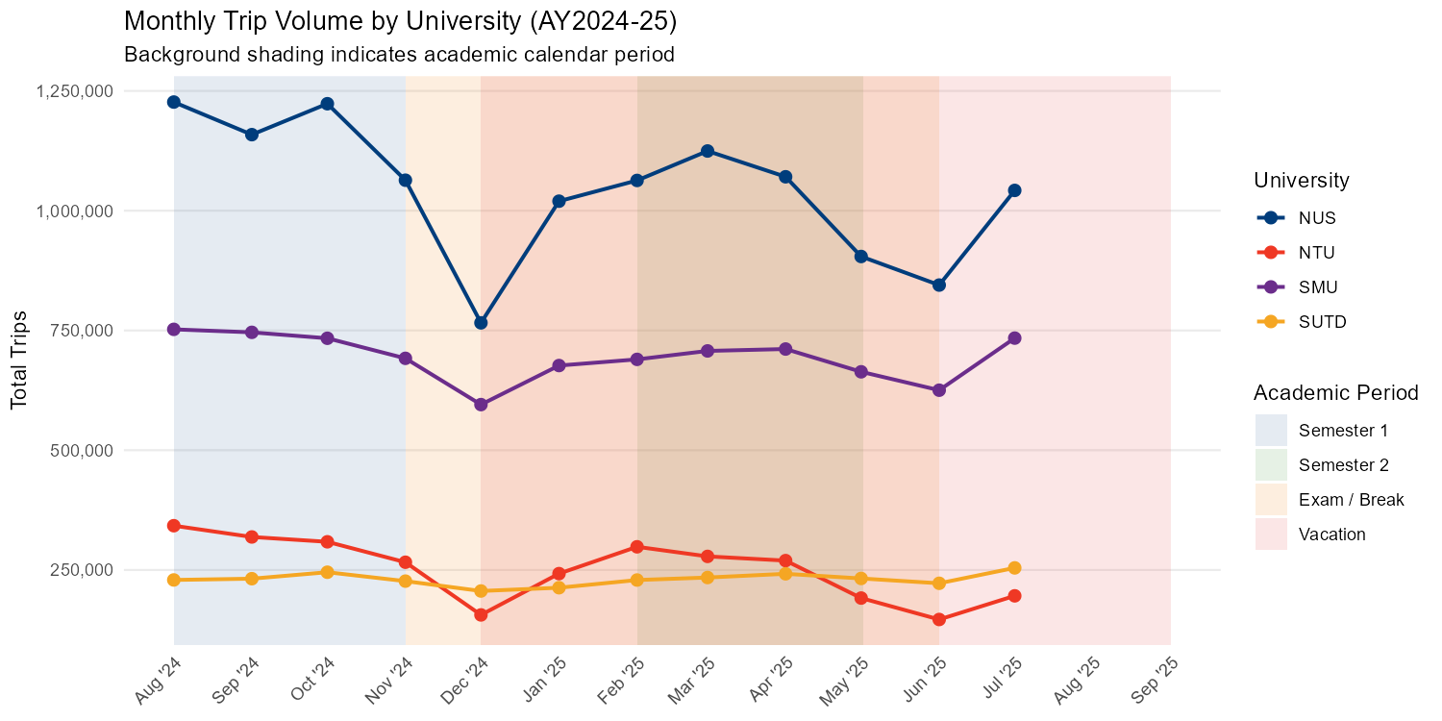
Figure 1.
3.4.2 University and Month Headmap
The heatmap (Figure 2) reinforces the patterns by normalizing within each university. The plot shows the relative intensity of each month independent of campus size. NUS and NTU show the strongest seasonal contrasts, indicating that ridership is closely tied to term-time activity. SMU’s tiles remain closer to white, indicating a more stable pattern. On the other hand, SUTD shows an unexpected increase in July 2025, which is surprising given that the university's start days are not until August. This warrants an investigation and verification against the raw data, as it may reflect an anomaly.
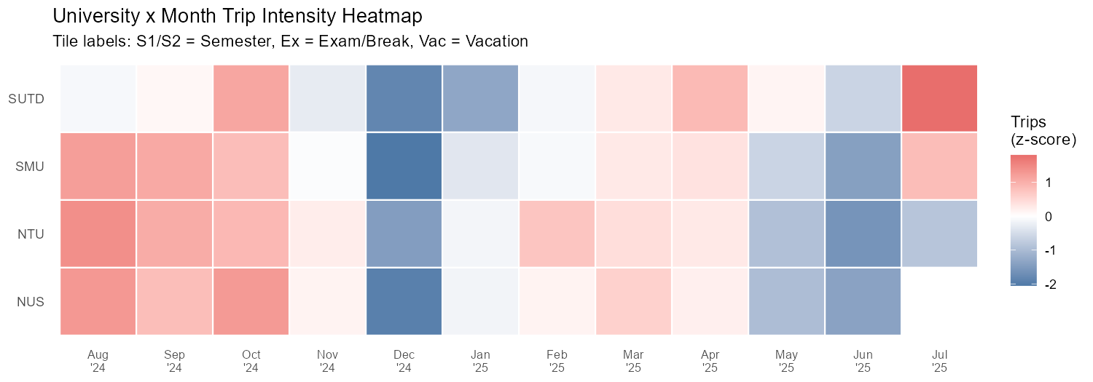
Figure 2.
3.4.3 Semester vs Vacation Comparison
Across the four universities, Semester 1 produces the highest mean monthly trip volumes, followed by Semester 2, Exam/Break, and Vacation in descending order (Figure 3).NTU demonstrated the steepest proportional decline from semester to vacation, while SMU and SUTD show relatively lower differences between the periods. The wide error bars for NTU during the Exam/Break period reflect high month-to-month variability within that short period, which amplifies any single-month fluctuation.
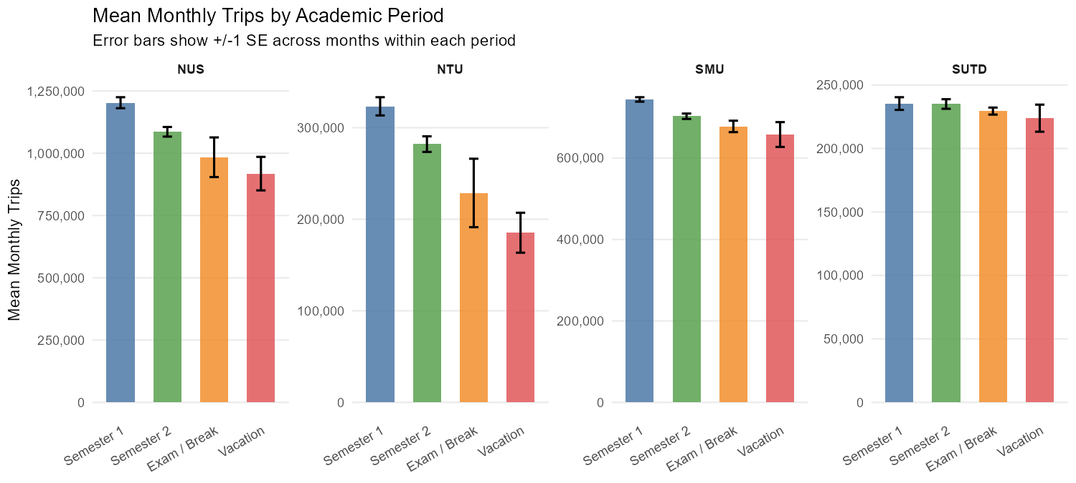
Figure 3.
3.4.4 Intra-day Analysis
Evening trips (from 1600 to 2200 hours) account for the largest share of daily trips across all universities (Figure 4). They typically account for 55-70% of weekday travel. This is quite consistent with the evening departure expected from a campus-origin dataset, where students and staff leave the campus after classes or work. Afternoon trips (from 1000 to 0400 hours) account for the second-largest share. SUTD is observed to have a rather large share of morning trips (0600 to 1000 hours) relative to the evening share compared to the other three Universities. Likely, this reflects its East location in Tampines, where residents might rely more on early-morning public transport. SMU shows a somewhat higher share during night hours (2200 to 0600), which can be explained by its location in the city center and its closeness to nightlife venues and food and beverage areas in the civil districts. The district is near Clarke Quay, Orchard Road, and several other entertainment and dining districts, which attract a myriad of night activities. This implies that a portion of SMU-origin trips may be directed to or return from late-light destinations, a pattern much less observed at other universities. Intra-day patterns remain consistent across academic periods, indicating that the time-of-day travel structure is habitual and experiences minimal variation between semesters and vacation periods.
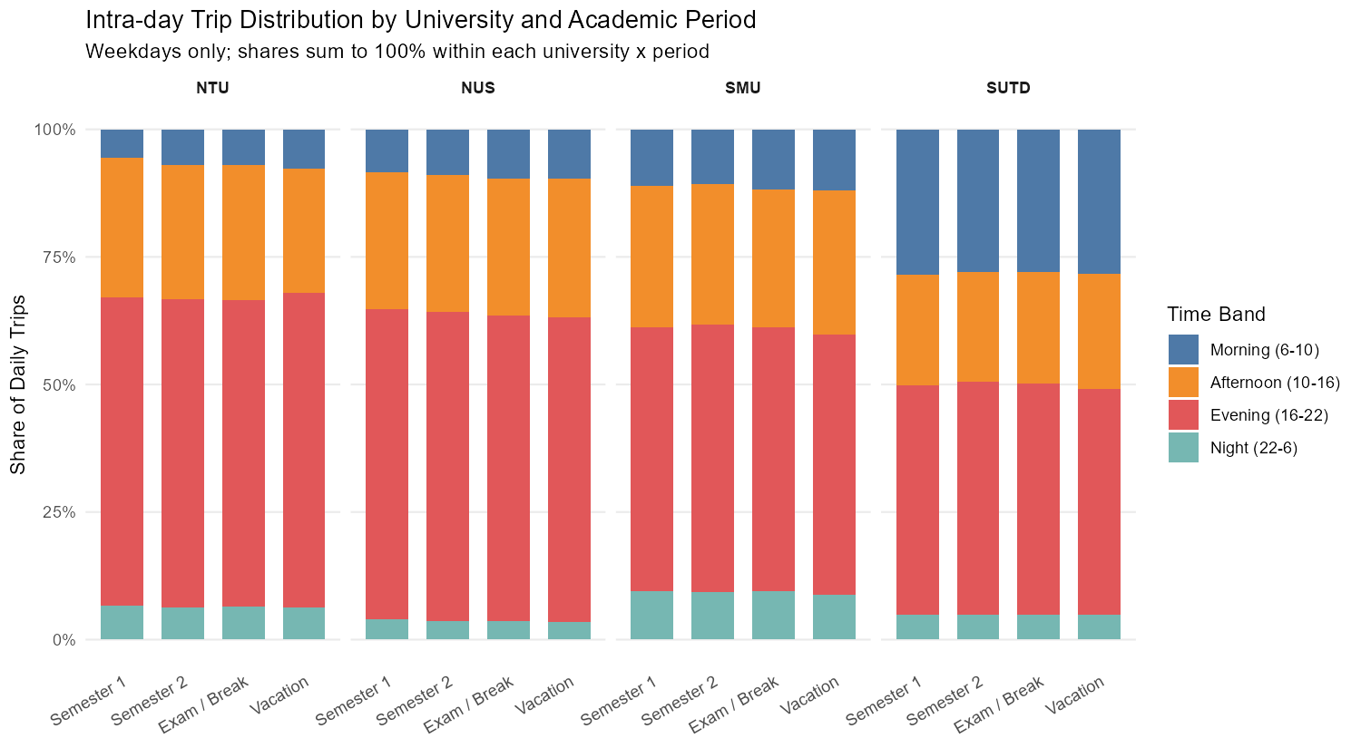
Figure 4: Intra-day trip distribution by university and academic period on weekdays. Different bands register to different time periods.
3.4.5 Destination Function Analysis
NTU trips are more concentrated in Mixed-Use and Community Destinations (at 75%), with Retail & Personal Care accounting for most of the remaining share, with very little Dining & Hospitality. This demonstrates the suburban residential nature of the areas around Boon Lay, the site of NTU campus. NUS, on the other hand, shows more balanced splits across Mixed-Use & Community (~45%), Retail & Personal Care (~25%), and Dining & Hospitality (~25%), pointing to a wider variety of destination types accessible from the Kent Ridge Campus. SMU’s destination profile is rather similar to NUS’s, which is unsurprising as SMU is in the heart of the commercial and civic districts. SUTD, on the other hand, is the most distinctive, showing a much higher Retail & Personal Care share (~50%), particularly in the vacation periods, as well as the highest Industrial & Automotive component. This is also consistent with its campus location in Tampines, which is surrounded by regional retail malls and light industrial zones (Changi Business Park). Destination function proportions are generally stable across the academic spectrum periods for the universities, suggesting that the students’ travel does not change substantially between the term and vacation periods, but rather in how frequent their travel changes.
NUS stacked area chart (Figure 5) further confirms the temporal stability of the destination function shares, where all the function types are near constant proportions.

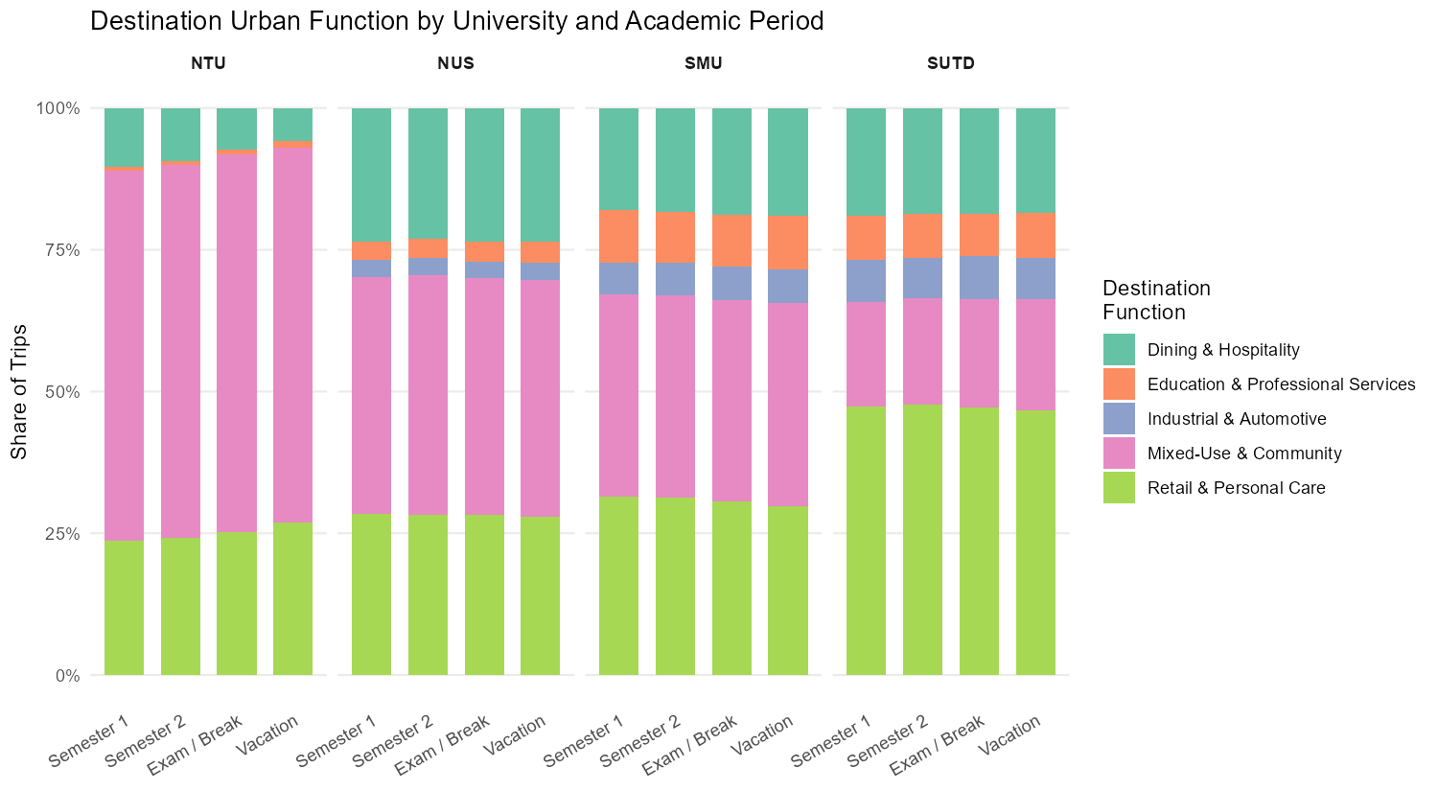
Figure 5
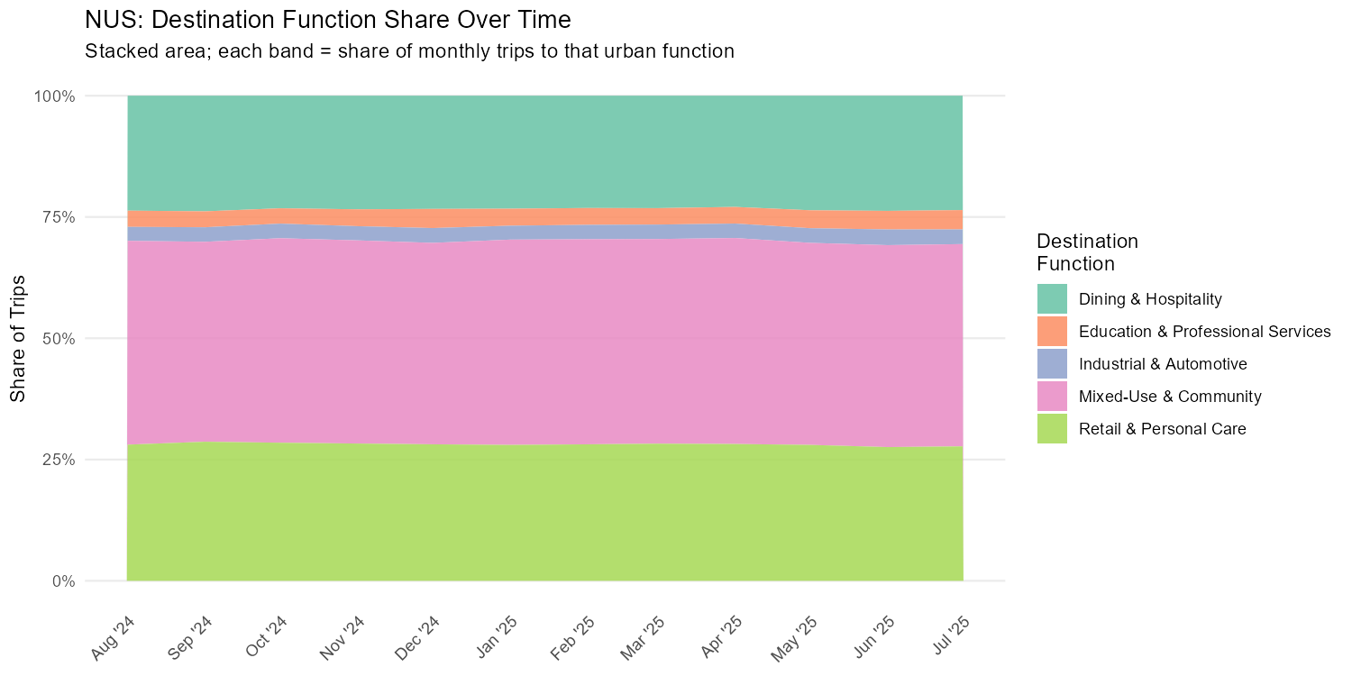
Figure 6
3.5 Discussion and Conclusion
This analysis yields several findings that warrant further investigation. The most consistent finding across all four universities is that the academic calendar affects how much university communities travel far more than it affects how or where they travel. Intra-day distributions and destination function profiles remain stable across the semester, examination, and vacation periods, while the aggregate monthly volumes fluctuate substantially. If travel structure were solely a function of academic obligation, one would expect meaningful shifts in time-of-day patterns or destination types during vacation periods. The absence of such shifts implies that habitual travel behavior, once established during the semester, persists into vacation periods even as overall frequency declines, which is rather consistent with the concept of travel habit strength in behavioral transport research(Verplanken et al., 1997).
The considerable differences in destination function profiles across the four universities point to geographical context as a more powerful determinant of destination choice rather than institutional type or student demographics. SUTD’s retail-heavy profile and NTU’s Mixed-Use and Community focus are better explained by the environmental context than any campus-specific characteristics. This has implications for transit planning where service investments from the campuses may be better calibrated to the surrounding urban context than to generic assumptions about student travel preferences.
SMU, on the other hand, has a flat seasonal profile, which is the most interesting deviation from the general pattern. The campus's location places it at a junction of multiple high-density land uses, generating transit demand independent of academic cycles and diluting campus-specific seasonal signals. Also, the school’s lack of on-campus dormitories may also mean its community members are more integrated into the surrounding urban environment year-round, which will definitely result in a higher transit usage even during vacation weeks.
Several limitations for the present findings exist. Firstly, the OD dataset does not distinguish individual traveler types, such as trips made by students, staff,, or non-campus personnel; all stations are aggregated, which is even more consequential for SMU,, where the stations are located in a very dense, mixed-use environment. Secondly, the academic calendar classification is based on the NUS calendar and applied across all four schools, which does not really capture the fine-grained differences in examination dates, recesses, and reading weeks. Thirdly, the 100 meter buffer used to define the campus stations is pragmatic but there is also the issue of how the stations may serve non-university populations, which introduces noise into the campus trip counts. Finally, the destination function analysis is constrained to trips terminating at stations, which may not reflect the full destination distribution for university-origin trips.
3.6 References
Kashfi, S. A., Bunker, J. M., & Yigitcanlar, T. (2015). Understanding the effects of complex seasonality on suburban daily transit ridership. Journal of Transport Geography, 46, 67–80. https://doi.org/10.1016/j.jtrangeo.2015.05.008
Verplanken, B., Aarts, H., & Van Knippenberg, A. (1997). Habit, information acquisition, and the process of making travel mode choices. European Journal of Social Psychology, 27(5), 539–560. https://doi.org/10.1002/(SICI)1099-0992(199709/10)27:5%253C539::AID-EJSP831%253E3.0.CO;2-A

